**PURBANCHAL UNIVERSITY**



**Faculty of Science and Technology**

Biratnagar, Nepal



# KIST College of Information and Technology

Kamalpokhari, Kathmandu

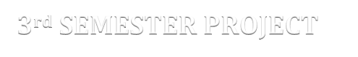

**3rd SEMESTER PROJECT**

**ON**

**“Attendance System”**

In the partial fulfillment for the requirement of the 3rd Semester Project - III (**Subject code – BIT278CO**) in the completion of Bachelor of Information Technology (BIT) degree at KIST college of Information Technology, under Purbanchal University.

|  |  |  |  |
| --- | --- | --- | --- |
| **Submitted By** |  |  | **Submitted To** |
| Kshitiz GC | 334461 |  | Purbanchal University |
| Manoram Subedi | 334462 |  |  |
| MD Samsad Ali | 334464 |  |  |
| Saroj Adhikari | 334479 |  |  |

# ACKNOWLEDGEMENT

We take this opportunity to express our gratitude and unfathomable regards to the Information Technology (IT) department for this commendable guidance, monitoring and constant encouragement throughout the course of this project. The help and guidance given by shall carry us the long way, in the journey in which we are about to commence.

We also take this opportunity to express a deep sense of gratefulness to our college’s IT department coordinator Mr. Deepak Khadka as well as our project teacher Mr. Mohammad Faijan for his amiable support, valuable information and guidance which helped us in completing this task throughout its various stages. We are indebted to all members of KIST College, for the valuable support and suggestion provided by them using their specific fields’ knowledge. We are grateful for their cooperation during the period of our project.

We would also like to express our gratefulness towards Purbanchal University for designing such a wonderful course structure. It will help us to get more knowledge in the field of Information Technology & help us to have a bright future in the field of technology.

Thank You.

# STUDENT’S DECLARATION

We following students, hereby declared that the project report entitled **“ATTENDANCE SYSTEM”** is a result of our own work and our indebtedness to other work publications, references, if any, have been dully acknowledged.

We further certify that this Project submitted in partial fulfillment of the requirement for the award of Bachelor in Information Technology (BIT) of the Purbanchal University is our original work and has not been submitted for award of any other degree or other similar title or prize.

|  |  |  |  |
| --- | --- | --- | --- |
| **S.N.** | **Name** | **Registration No.** | **Symbol No.** |
| **1** | Kshitiz GC |  | 334461 |
| **2** | Manoram Subedi |  | 334462 |
| **3** | MD Samsad Ali |  | 334464 |
| **4** | Saroj Adhikari |  | 334479 |

# EXAMINER’S CERTIFICATION

**The Project Report**

**On**

**“Attendance System”**

**Developed By:**

**Kshitiz GC**

**Manoram Subedi**

**MD Samsad Ali Saroj Adhikari.**

is approved and is acceptable in quality and form.

…………………………………. ………………..…………………

**Internal Examiner External Examiner**

Name: Name:

Designation: Designation:

# TO WHOM IT MAY CONCERN

This is to certify that **Mr. Kshitiz GC, Mr. Manoram Subedi, Mr. MD Samsad Ali** and **Mr. Saroj Adhikari** of Bachelor in Information Technology (**BIT**) has studied as per the curriculum of BIT 3rd semester and completed the project entitled **“Attendance System”.**

This project is the original work of Mr. Kshitiz GC, Mr. Manoram Subedi, Mr. MD Samsad Ali and Mr. Saroj Adhikari and was carried out under the supervision as per guidelines provided by Purbanchal University and certified as per the students declaration that project **“Attendance System”** has not been presented anywhere as a part of any other academic work.

**The details of the students are as follows:**

|  |  |  |  |
| --- | --- | --- | --- |
| **S.N** | Kshitiz GC | **Registration No.** | **Symbol No.** |
| **1** | Kshitiz GC |  | 334461 |
| **2** | Manoram Subedi |  | 334462 |
| **3** | MD Samsad Ali |  | 334464 |
| **4** | Saroj Adhikari |  | 334479 |

**Course Semester:** **-** 3rd Semester

**Subject:** **-** Project-III

**Subject code:** **-** BIT278CO

……………………………………..

**Mr. Mohammad Faijan**

**Project Instructor, BIT**

**KIST College of Information Technology**

**Table of Content:**

1. Abstract of the project
2. Introduction about project
3. Future Prospect of the project
4. Programming Language and Framework Used
5. Integrated Development Environment & Database
6. System Requirement
7. Database Table Structure
8. Use Case Diagram
9. Screenshots
10. Limitations
11. Conclusion
12. Bibliography

# Abstract of the project

Attendance System is desktop-based application software created using **C# language** along with **.NET framework** and **MetroFramework**. This is user friendly software which is aimed to be used by the college administrator or teacher to keep daily record of students.

This system includes the features of database (Microsoft SQL Server) which allows the user to add, delete, modify and search required record. This system has features adding new classes or students into the records, updating status of students etc.

# Introduction about project

Attendance System is a computer software that manages the records of students and courses. This software helps to store the student detail in a simple manner. This software “Attendance System” provides various different functionalities. Most of the times the recording of student details is done in a physical piece of paper that can be lost or tore down. So, this software aims to solve that problem. With the use of this software Schools, colleges and other educational institutions don’t have to worry about losing the details of their students. The student’s details can be stored instantly and also be retrieved when necessary. This software is easy to use and works efficiently even in older computer devices.

# Objective of the project

The prime objectives Attendance System are listed below:

* To make the record keeping more effective.
* To provide different types of information and record on a single platform so that the user doesn’t have to go through tedious process of finding and collecting different information.
* To retrieve the data of any specific date.
* To save time and increase accuracy in work.
* To reduce the paper work by computerizing the data entry procedure.

# Future Prospect of the project

Though this project is a simple demo version of actual Attendance System, it has got promising implementation for the future too. Further enhancement is necessary for this system as the limitations can’t be denied but can be resolved by better technologies.

The following are the future scope for the project:

* It can be made as a Web application. Currently this system is desktop-based system.
* The number of people using the software can be increased as per the requirement.

# Programming Language and Framework Used

## C#

C# is a general-purpose, modern and object-oriented programming language pronounced as “C sharp”. It was developed by Microsoft led by Anders Hejlsberg and his team within the .Net initiative and was approved by the European Computer Manufacturers Association (ECMA) and International Standards Organization (ISO). C# is among the languages for Common Language Infrastructure and the current version of C# is version 7.2. C# is a lot similar to Java syntactically and is easy for the users who have knowledge of C, C++ or Java.

C# is one of the popular and demanding languages because it is easy to start, widely used for developing desktop application, web application and is popular in game development also.

## .NET Framework

.NET is a software framework which is designed and developed by Microsoft. The first version of .Net framework was 1.0 which came in the year 2002. In easy words, it is a virtual machine for compiling and executing programs written in different languages like C#, VB.Net etc.

It is used to develop Form-based applications, Web-based applications and Web services. There is a variety of programming languages available on the .Net platform, VB.Net and C# being the most common ones are. It is used to build applications for Windows, phone, web etc. It provides a lot of functionalities and also supports industry standards.

## WinForms

Windows Forms is a smart client technology for the .NET Framework, a set of managed libraries that simplify common application tasks such as reading and writing to the file system.

Windows Forms ("WinForms" for short) is a GUI class library included with the .NET Framework. It is a sophisticated object-oriented wrapper around the Win32 API, allowing the development of Windows desktop and mobile applications that target the .NET Framework.

WinForms is primarily event-driven. An application consists of multiple forms (displayed as windows on the screen), which contain controls (labels, buttons, textboxes, lists, etc.) that the user interacts with directly. In response to user interaction, these controls raise events that can be handled by the program to perform tasks. WinForms has been supported since the original version of the .NET Framework (v1.0), and is still available in modern versions (v4.5).

# Integrated Development Environment (IDE) & Server

## Visual Studio

IDE is a term commonly used in the programming world to describe the interface and environment that we use to create our applications. It is called integrated because it allows virtually accessibility of the entire development tool that we need for one screen called an interface. The IDE is also commonly referred to as the design environment, or the program. Integrated development is one in which we can develop, run, text and debug applications.

Visual Studio is an Integrated Development Environment (IDE) developed by Microsoft to develop GUI (Graphical User Interface), console, Web applications, web apps, mobile apps, cloud, and web services, etc. With the help of this IDE, you can create managed code as well as native code. It uses the various platforms of Microsoft software development software like Windows store, Microsoft Silverlight, and Windows API, etc. It is not a language-specific IDE as you can use this to write code in C#, C++, VB (Visual Basic), Python, JavaScript, and many more languages. It is available for Windows as well as for macOS.

This project has used community edition of Microsoft Visual Studio.

**Community** edition is a **free** version which is announced in 2014. *All other editions are paid*. This contains the features similar to Professional edition. Using this edition, any individual developer can develop their own free or paid apps like *.Net applications*, Web applications and many more. In an enterprise organization, this edition has some limitations.

## Microsoft SQL Server

Microsoft SQL Server is a relational database management system (RDBMS) that supports a wide variety of transaction processing, business intelligence and analytics applications in corporate IT environments. Microsoft SQL Server is one of the three market-leading database technologies, along with Oracle Database and IBM's DB2.

Like other RDBMS software, Microsoft SQL Server is built on top of SQL, a standardized programming language that database administrators (DBAs) and other IT professionals use to manage databases and query the data they contain. SQL Server is tied to Transact-SQL (T-SQL), an implementation of SQL from Microsoft that adds a set of proprietary programming extensions to the standard language.

SQL Server Management Studio (SSMS) is the main interface tool for SQL Server, and it supports both 32-bit and 64-bit environments.

# System Requirement

## Supported Operating Systems

Visual Studio 2019 will install and run on the following operating systems (64 bit recommended; ARM is not supported):

Windows 10 version 1703 or higher: Home, Professional, Education, and Enterprise (LTSC and S are not supported)

## Hardware

1.8 GHz or faster processor. Quad-core or better recommended

2 GB of RAM; 8 GB of RAM recommended (2.5 GB minimum if running on a virtual machine)

Hard disk space: Minimum of 800MB up to 210 GB of available space, depending on features installed; typical installations require 20-50 GB of free space.

Hard disk speed: to improve performance, install Windows and Visual Studio on a solid state drive (SSD).

# Table Structure

## AttendanceRecordTBL

|  |  |  |
| --- | --- | --- |
| **Column Name** | **Null** | **Data Type** |
| RecNum (Primary Key) | Not null | int |
| StudentID | Not null | int |
| ClassID | Not null | int |
| DateAtt | Not null | date |
| Status | Not null | Nchar(10) |
| StudentName | Not null | nvarchar(50) |
| ClassName | Not null | nvarchar(50) |

## ClassesTBL

|  |  |  |
| --- | --- | --- |
| **Column Name** | **Null** | **Data Type** |
| ClassID (Primary Key) | Not null | int |
| ClassName | Not null | nchar(50) |
| UserID | Not null | int |

## StudentsTBL

|  |  |  |
| --- | --- | --- |
| **Column Name** | **Null** | **Data Type** |
| StudentID (Primary Key) | Not null | int |
| StudentName | Not null | nvarchar(50) |
| ClassID | Null | int |

## Users

|  |  |  |
| --- | --- | --- |
| **Column Name** | **Null** | **Data Type** |
| UserID (Primary Key) | Not null | int |
| UserName | Not null | nchar(50) |
| PassWord | Not null | nchar(250) |

# User Case Diagram

A use case diagram at its simplest is a representation of a user's interaction with the system that shows the relationship between the user and the different use cases in which the user is involved. The purpose of a use case diagram in UML is to demonstrate the different ways that a user might interact with a system. In the following use case diagram of Attendance System, the interaction of two actors – user and admin is shown:

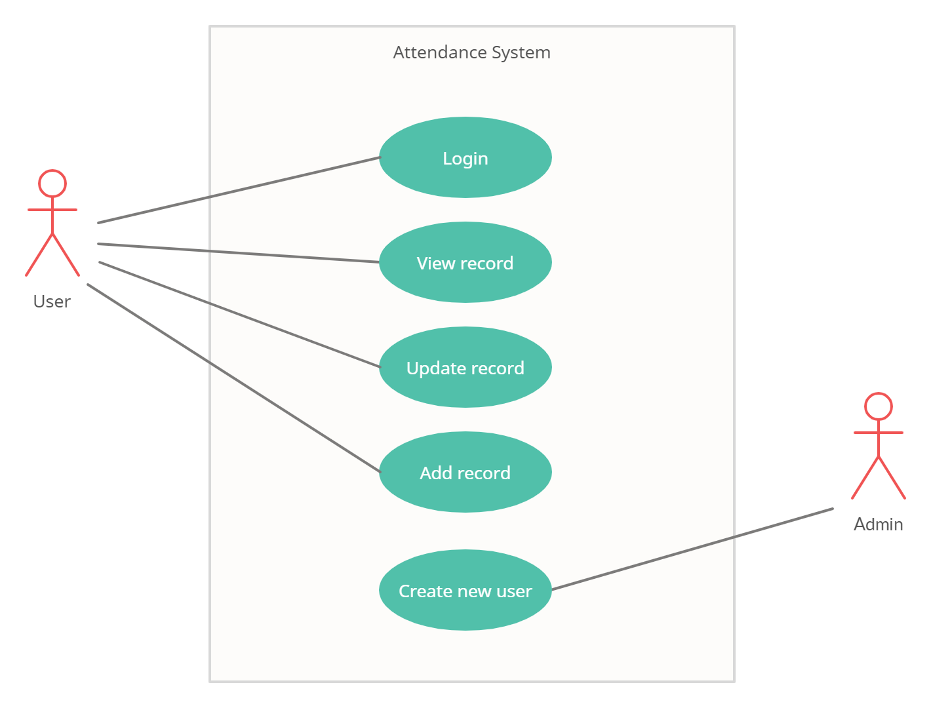

# Screenshots

## 1. Login

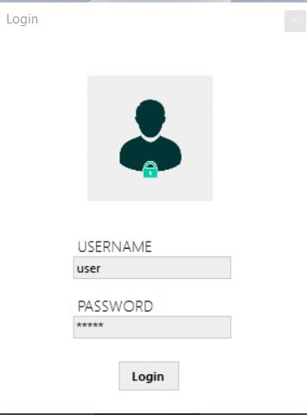

## 2. Student Info

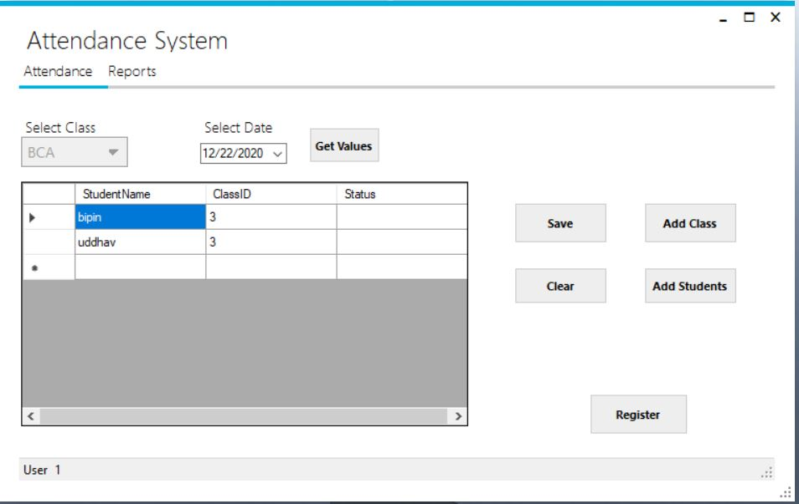

## 3. Add new class

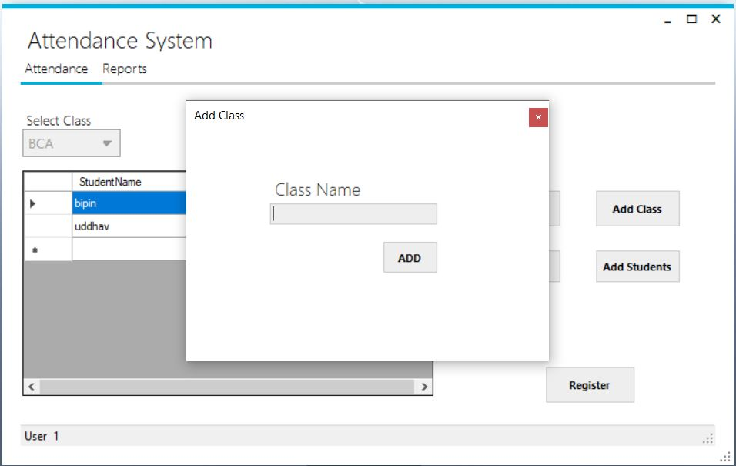

## 4. Add New Student

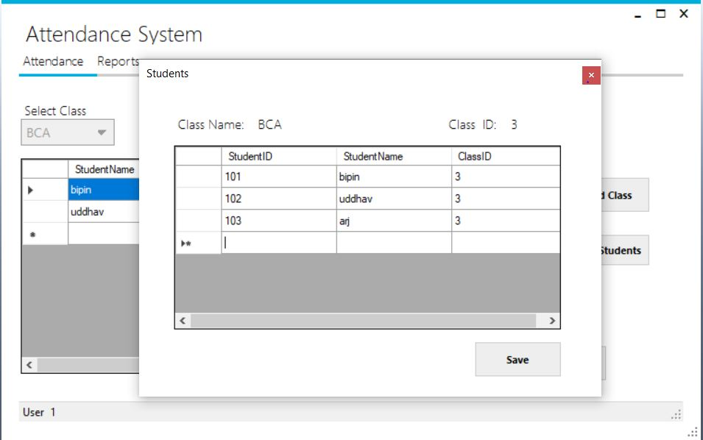

## 5. View Report

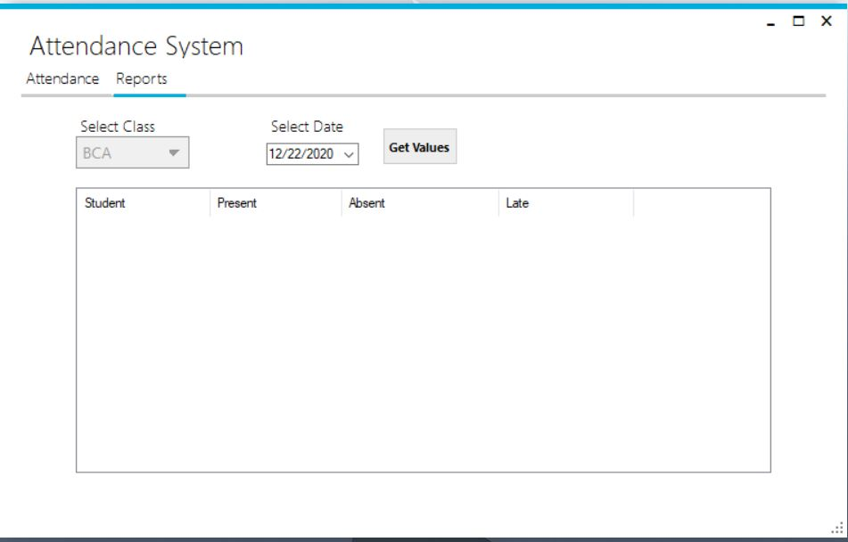

## 6. Register New User

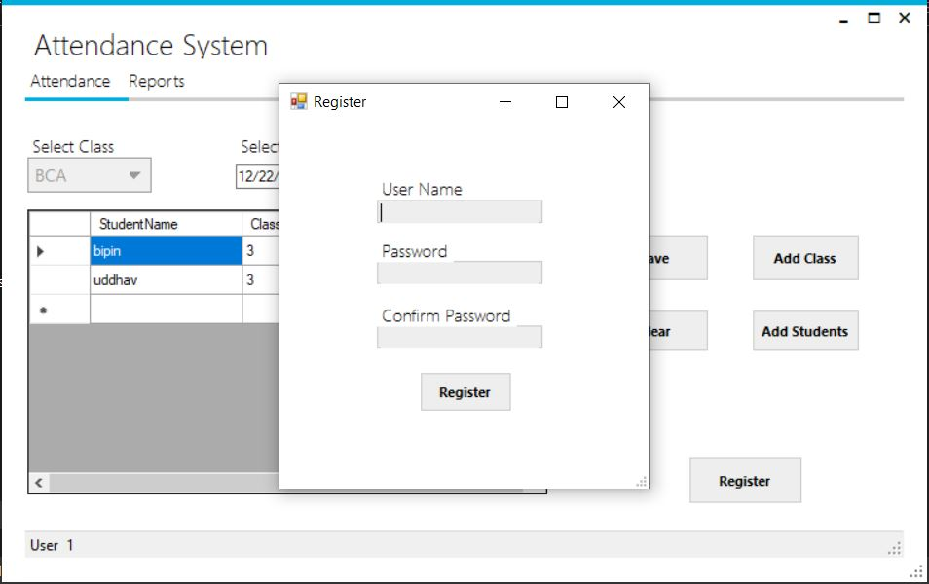

# Limitations

* This system called “Attendance System” is platform dependent.
* Lack of secured data and security.
* Online based application is not supported.
* Lacks some important features.

# Conclusion

The project titled “Attendance System” developed under Windows environment using .NET framework is an attempt to implement the proposed system. It was a great opportunity for us to learn about C# programming language. This whole project duration helped us to get the glimpse of practical usage of the knowledge that we learn in the real world.

The main objective of the project is to computerize the existing system where all the process was carried out manually.

# Bibliography

* SQl with C#, Klaus Elk
* Visual C# 2012 How To Program, Paul Deitel & Harvey Deitel, Fifth Edition
* Visual C# Programming - https://www.c-sharpcorner.com/csharp-tutorials
* https://www.guru99.com/c-sharp-access-database.html